MATHEMATICS SPECIALIST

MAWA Year 12 Examination 2019

Calculator-free

Marking Key

© MAWA, 2019
Licence Agreement
This examination is Copyright but may be freely used within the school that purchases this licence.
- The items that are contained in this examination are to be used solely in the school for which they are purchased.
- They are not to be shared in any manner with a school which has not purchased their own licence.
- The items and the solutions/marking keys are to be kept confidentially and not copied or made available to anyone who is not a teacher at the school. Teachers may give feedback to students in the form of showing them how the work is marked but students are not to retain a copy of the paper or marking guide until the agreed release date stipulated in the purchasing agreement/licence.

The release date for this exam and marking scheme is
- the end of week 1 of term 4, 2019

Question 1 (4 marks)
Solution
Equation of the curve that passes through the point is
Mathematical behaviours | Marks
- anti-differentiates using  - anti-differentiates using a factor of one-third  - substitutes the coordinates into the anti-derivative function to determine the constant of integration correctly  - states the equation of the curve containing correctly | 1  1  1  1

Question 2(a) (3 marks)

Solution
Since
then with

we obtain

Mathematical behaviours | Marks
- identifies the correct substitution  - integrates correctly  - evaluates the indefinite integral at the end points | 1  1  1

Question 2(b) (3 marks)

Solution
Since

it follows that

Mathematical behaviours | Marks
- simplifies the integral to requiring the anti-derivative of  - integrates correctly  - evaluates the indefinite integral at the end points | 1  1  1

Question 2(c) (3 marks)

Solution
If we put
then we find that
Mathematical behaviours | Marks
- calculates correctly  - substitutes into integral changing the limits appropriately  - integrates the expression correctly | 1  1  1

Question 2 (d) (3 marks)

Solution
If we write

then we conclude that and whence and .

Hence

Mathematical behaviours | Marks
- writes the correct form of the partial fractions  - deduces the correct values of the constants and  - evaluates the integral correctly  - no penalty for omitting the arbitrary constant | 1  1  1

Question 3(a) (4 marks)

Solution
Assuming $a=2,$the system of equations reduces to
$x+0.5y+0.5z=0.5$ $0.5y-4.5z=-0.5$ $0.5y-2.5z=1.5$ (*)
and then to
$x+0.5y+0.5z=0.5$ $y-9z=-1$ $2z=2$ (**)
So $z=1$
Back substitution gives $y=8$ and $x=-4$
Mathematical behaviours | Marks
- eliminates first variable (*)  - eliminates second variable (**)  - back substitutes for second variable  - back substitutes for first variable | 1  1  1  1

Question 3(b) (2 marks)

Solution
The system of equations reduces to
$x+0.5y+0.5z=0.5$ $0.5y-4.5z=-0.5$ $0.5y+(a-4.5)z=1.5$
and then to
$x+0.5y+0.5z=0.5$ $y-9z=-1$ $az=2$ (*)
There is no solution if $a=0$
Mathematical behaviours | Marks
- eliminates first two variables (*)  - obtains correct answer | 1  1

Question 4(a)(i) (1 mark)
Solution
Mathematical behaviours | Marks
- verifies the result | 1

Question 4(a)(ii) (2 marks)

Solution
The equation has solutions
so that or .

Mathematical behaviours | Marks
- uses quadratic formula identifying the appropriate square root  - deduces the two solutions | 1  1

Question 4(b) (2 marks)

Solution
Since
we conclude that
Mathematical behaviours | Marks
- multiplies by the complex conjugate  - writes in polar form | 1  1

Question 4(c) (2 marks)

Solution
As this means that if the complex number is multiplied by the effect is to double the distance of the point in the Argand diagram from the origin. Moreover, the line joining the origin to is rotated anticlockwise through an angle

Mathematical behaviours | Marks
- recognises the effect is to double the distance from O  - comments that there is an anticlockwise rotation through | 1  1

Question 5(a) (2 marks)
Solution
The general equation of a plane is $r.n=c,$ so $2i+j-2k$ is a normal to the plane. (*)
Since $\left\|2i+j-2k\right\|=\sqrt{2^{2}+1^{2}+{(-2)}^{2}}=\sqrt{9}=3,$ $2/3i+1/3j-2/3k$ is a unit normal to the plane.
(So too is $-2/3i+1/3j-2/3k$.)
Mathematical behaviours | Marks
- obtains a normal to the plane (*)  - divides by the length to get a unit vector | 1  1

Question 5(b) (3 marks)

Solution
If $A(a,b,c)$ is the point on the plane closest to the origin then $2a+b-2c=18$
and $ai+bj+ck$ is normal to the plane.
So $ai+bj+ck=t(2i+j-2k)$ for some real number $t.$
So $2(2t)+t-2(-2)t=18,$i.e. $9t=18$ and so $t=2$.
So the coordinates of $A$ are $(4,2,-4$)
Mathematical behaviours | Marks
- recognizes that $OA$ is normal to the plane  - solves for the parameter $t$  - obtains correct answer | 1  1  1

Question 6(a) (4 marks)

Solution
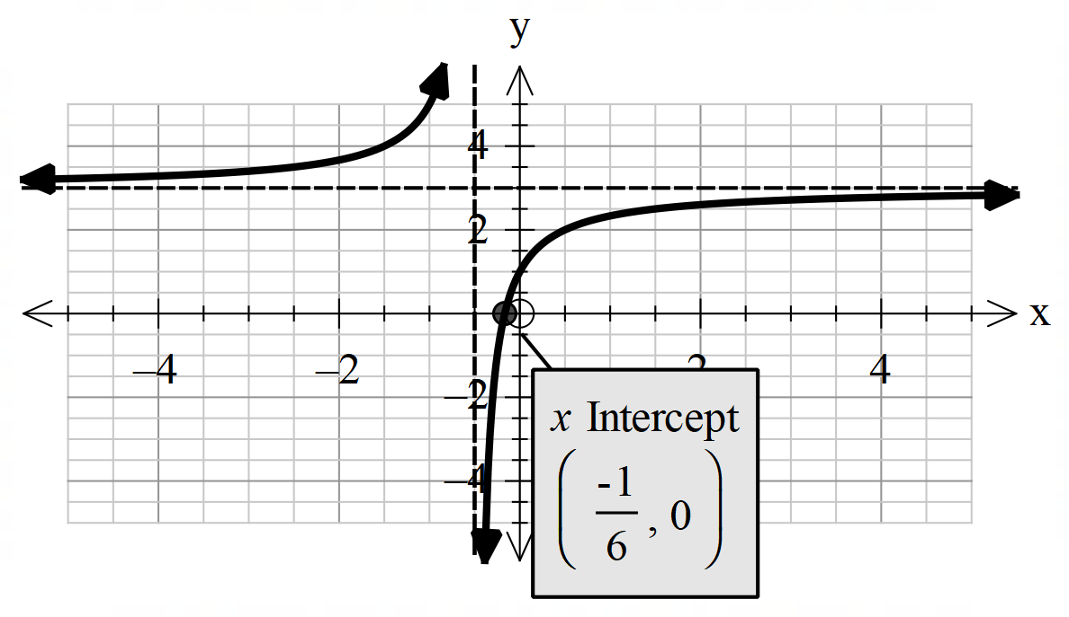

Mathematical behaviours | Marks
- indicates asymptote at correctly  - indicates asymptote at correctly  - indicates y-intercept at (0,1) and x-intercept at  - correct shape of the curve | 1  1  1  1

Question 6(b) (2 marks)

Solution
and will intersect at 2 points with positive x-coordinates
i.e.
has 2 non-negative roots if

Mathematical behaviours | Marks
- states that  - states that | 1  1

Question 7(a) (2 marks)

Solution
or
Mathematical behaviours | Marks
- uses tangent ratio to form a correct equation  - expresses in terms of correctly | 1  1

Question 7(b) (2 marks)

Solution
Mathematical behaviours | Marks
- uses quotient rule to differentiate correctly  - states correct expression in simplest form | 1  1

Question 7(c) (4 marks)
Solution
When x = 5,
(towards O) and so that
Then radians/sec

Mathematical behaviours | Marks
- identifies  - determines value of correctly when x = 5  - identifies correct expression for  - uses chain rule correctly with appropriate substitution to evaluate the value of | 1  1  1  1

Question 8(a) (2 marks)

Solution
This is false.
A confidence interval may contain none of the underlying population. (For example, if the population consists of an equal number of $0's$ and $1's$, and if the sample is large enough, then a 90% confidence interval will be a small interval of numbers near $0.5$ and will contain neither $0$ nor $1.$

Mathematical behaviours | Marks
- gives correct answer  - gives a valid reason | 1  1

Question 8(b) (2 marks)

Solution
This is false.
The probability that any one of the confidence intervals will contain $μ$ is 0.95. But it is possible that NONE of the twenty confidence intervals will contain $μ.$
Mathematical behaviours | Marks
- gives correct answer  - gives a valid reason | 1  1

Question 8(c) (2 marks)

Solution
This is true.
The width of the confidence interval is proportional to $1/\sqrt{n}$.
So to halve the width the sample size must be reduced by a factor of 4
Mathematical behaviours | Marks
- gives correct answer  - gives a valid reason | 1  1

